ExNo:7 //IF CONDITION//

PROGRAM:

<html>

<body>

<h2>IF CONDITION</h2>

<p>Display "Good day!" if the hour is less than 18:00:</p>

<p id="dine">Good Evening users!</p>

<script>

if (new Date().getHours() < 18)

{

document.getElementById("dine").innerHTML = "Good day!";

}

</script>

</body>

</html

OUTPUT:

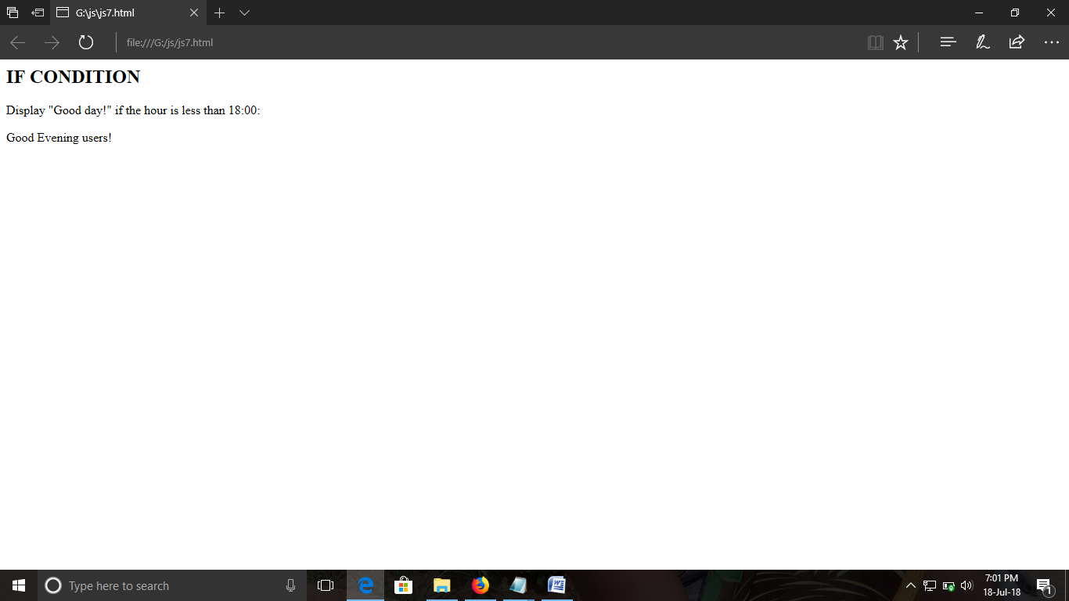

ExNo:8 //IF ELSE CONDITION//

PROGRAM:

<html>

<body>

<p>IF ELSE CONDITION</p>

<p>Click the button to display a time-based greeting:</p>

<button onclick="myFunction()">CLICK HERE</button>

<p id="demo"></p>

<script>

function myFunction() {

var hour = new Date().getHours();

var greeting;

if (hour < 18)

{

greeting = "Good day users";

}

else {

greeting = "Good evening users";

}

document.getElementById("demo").innerHTML = greeting;

}

</script>

</body>

</html>

OUTPUT:

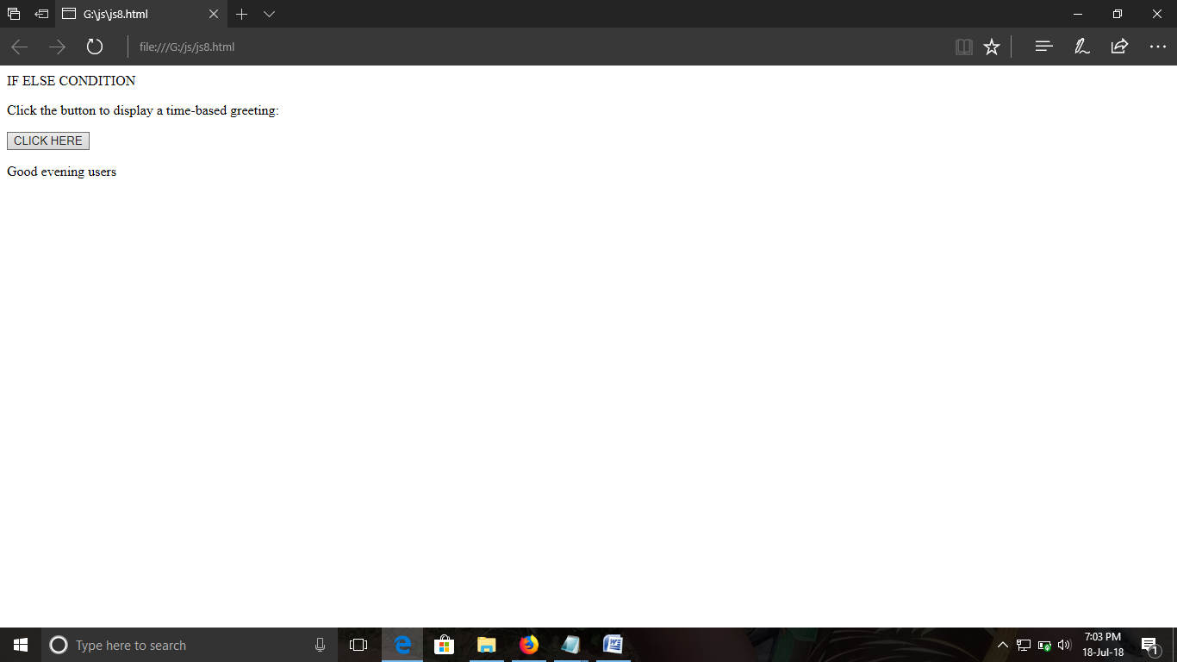

ExNo:9 //WHILE LOOP//

PROGRAM:

<html>

<body>

<p>the while program print the count</p>

<p id="one"></p>

<script>

var text = "";

var i = 0;

while (i < 6) {

text += "<br>The count is " + i;

i++;}

document.getElementById("one").innerHTML = text;

</script>

</body>

</html>

OUTPUT:

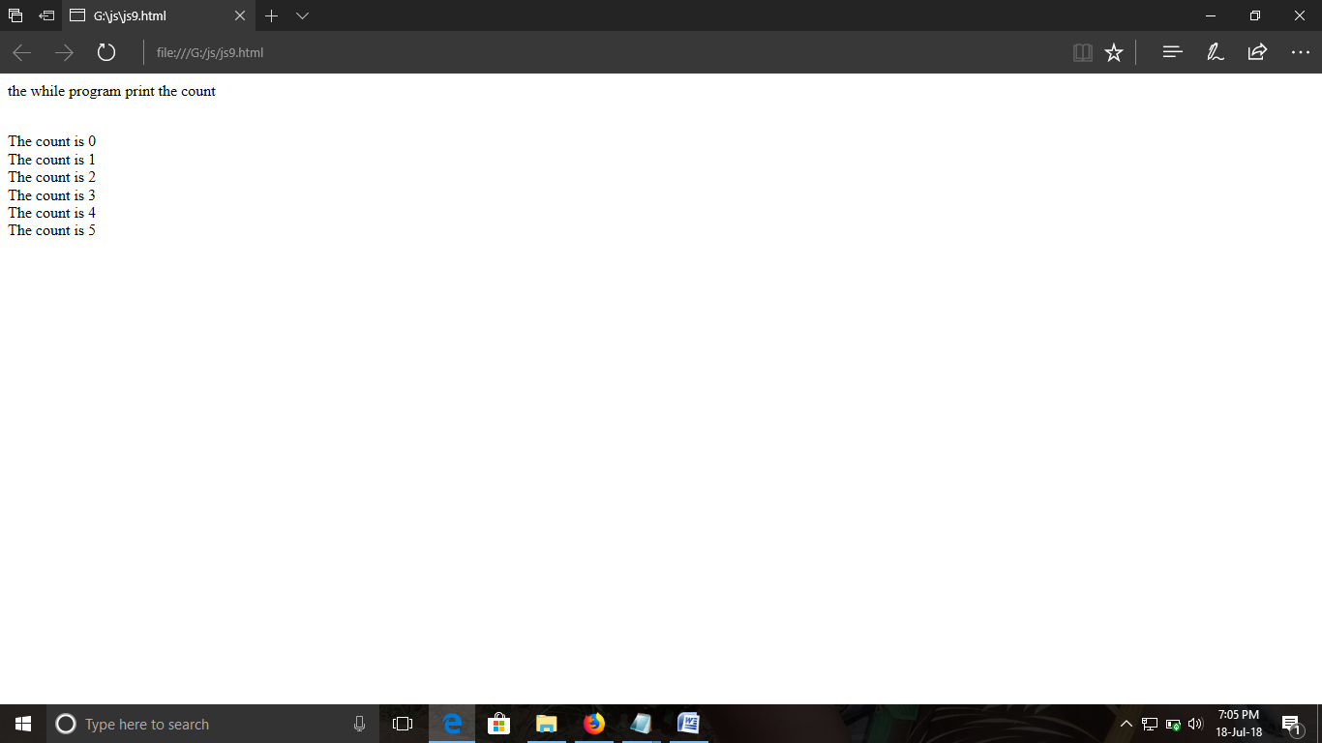

ExNo:10 //FOR LOOP//

PROGRAM:

<html>

<body>

<p>the for Loops print the count</p>

<p id="one"></p>

<script>

var i,text = "";

for (i = 0; i < 8; i++) {

text += "The count is " + i + "<br>";}

document.getElementById("one").innerHTML = text;

</script>

</body>

</html>

OUTPUT:

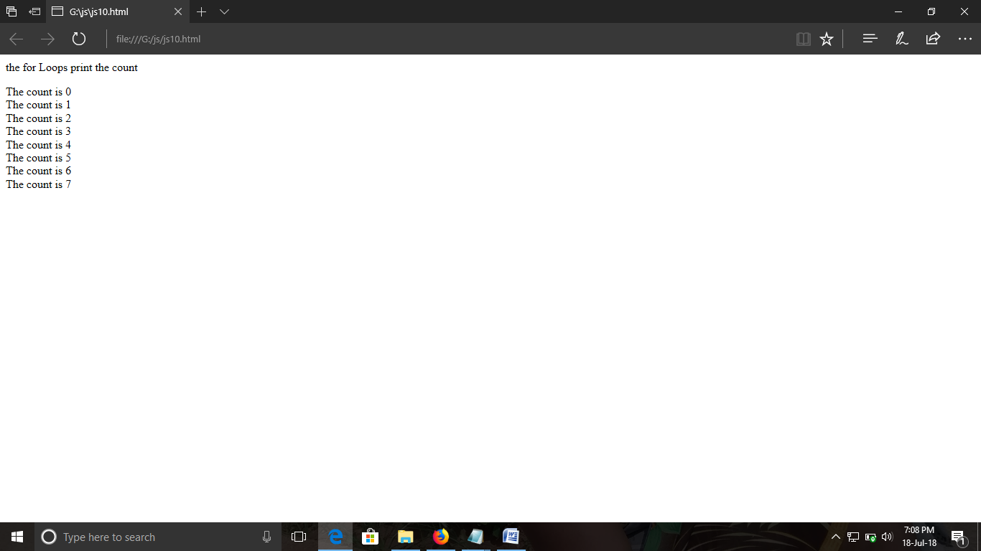

ExNo:11 //ARRAY//

PROGRAM:

<html>

<body>

<p>Js Arrays Program..<br>The program contain my family names..</p>

<p id="one"></p>

<script>

var family = ["DINESH", "SANTHOSH", "MURUGAN", "PARAMESHWARI"];

document.getElementById("one").innerHTML = family;

</script>

</body>

</html>

OUTPUT:

